1.Creat a new Repository and navigate path to that repository

2.show selected path

3.intialized empty git repository.

4.create new file and listed it

5.showed git status of file

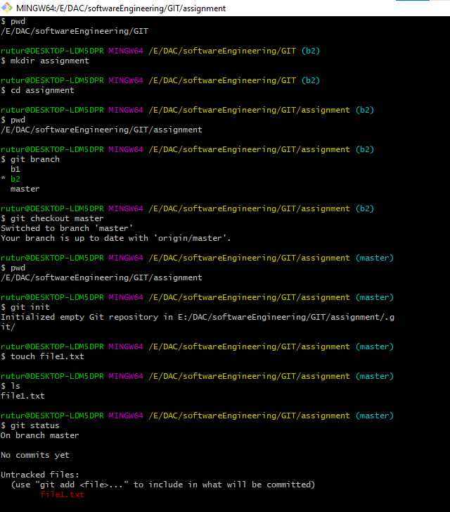

1. file adds to the stage area from working directory
2. File committed to the LOCAL REPOSITORY from stage area.

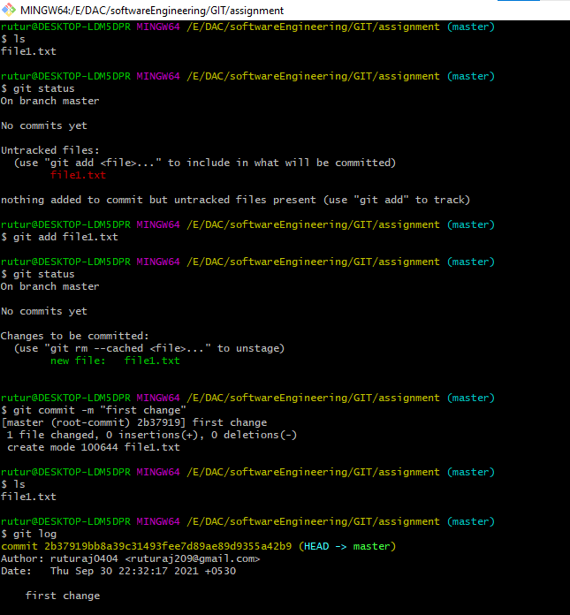

1. check status of modified file on local repository
2. commit modified file
3. revert changes
4. check status

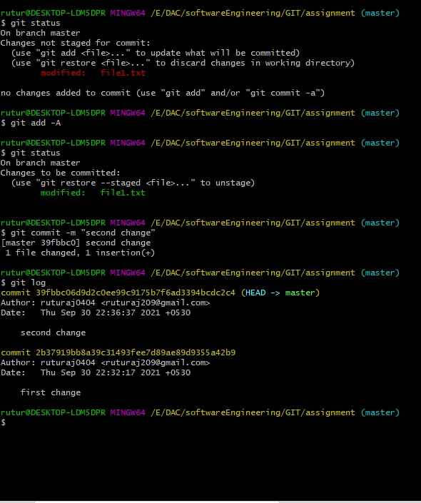

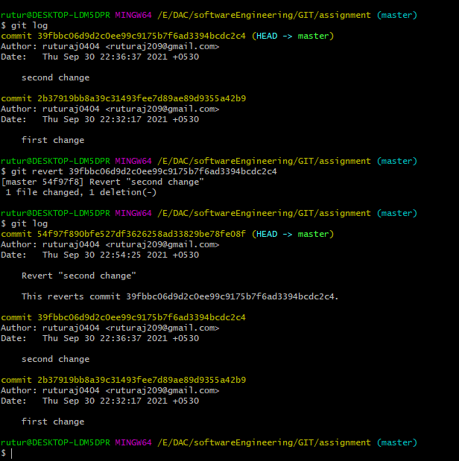

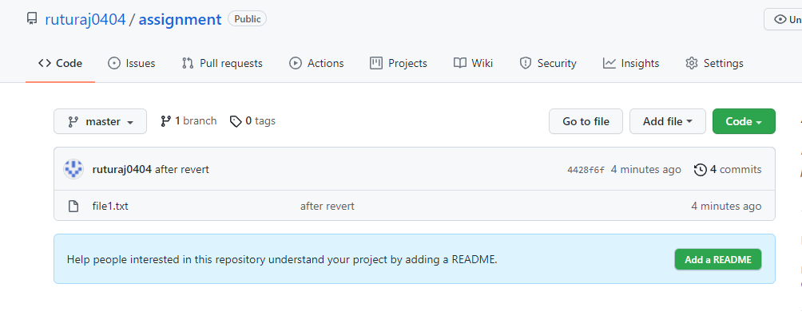

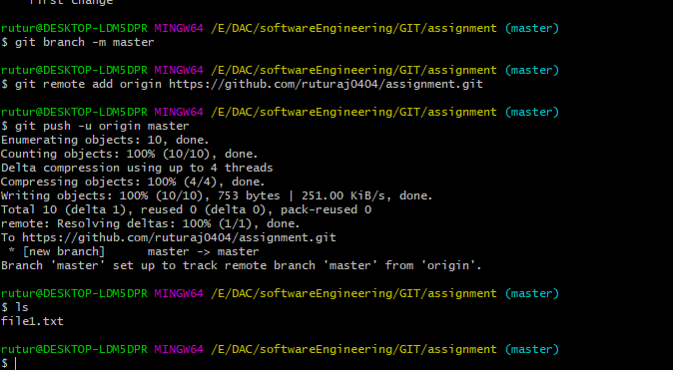

12.push data to remote repository

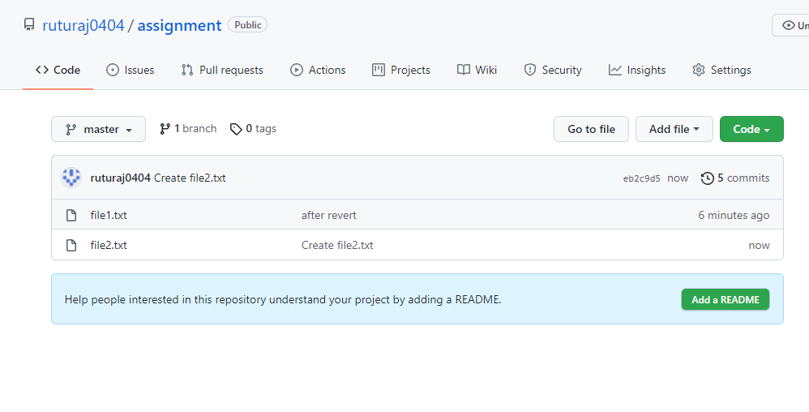

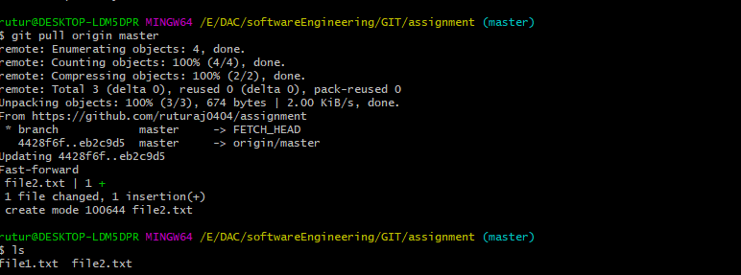13.pull data from remote repository to working directory

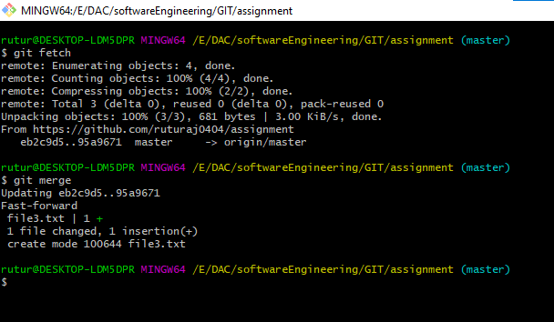14.featch and merge data from remote

15.git reset command

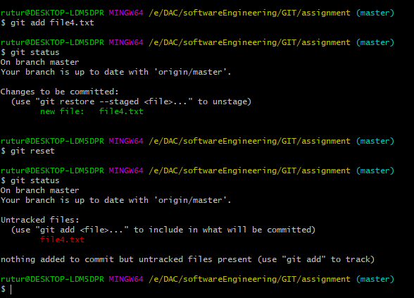

16.creat branches and merge

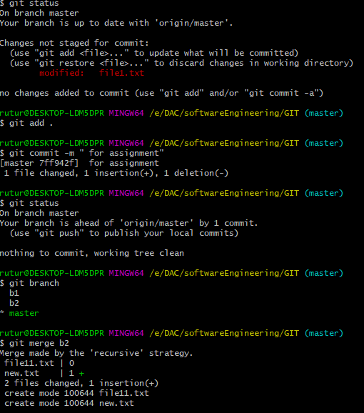

17.delete branches

